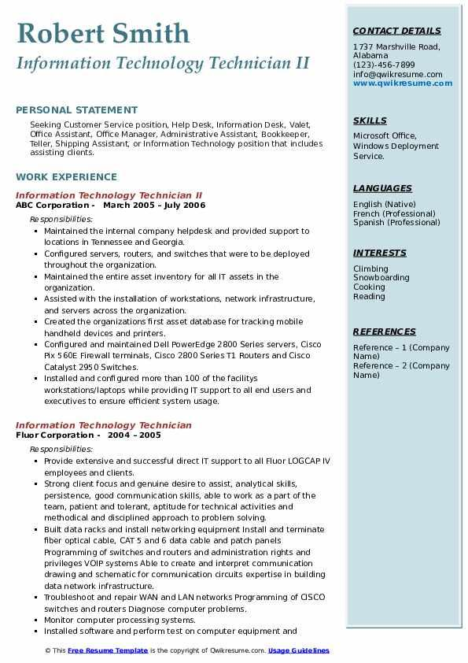
Robert Smith Information Technology Technician II
CONTACT DETAILS
1737 Marshville Road, Alabama
(123)-456-7899
info@qwikresume.com www.qwikresume.com
PERSONAL STATEMENT
Seeking Customer Service position, Help Desk, Information Desk, Valet, Office Assistant, Office Manager, Administrative Assistant, Bookkeeper, Teller, Shipping Assistant, or Information Technology position that includes assisting clients.
WORK EXPERIENCE
Information Technology Technician II
ABC Corporation March 2005 July 2006
Responsibilities:
• Maintained the internal company helpdesk and provided support to locations in Tennessee and Georgia.
• Configured servers, routers, and switches that were to be deployed throughout the organization.
• Maintained the entire asset Inventory for all IT assets in the organization.
• Assisted with the installation of workstations, network infrastructure, and servers across the organization.
• Created the organizations first asset database for tracking mobile handheld devices and printers.
• Configured and maintained Dell PowerEdge 2800 Series servers, Cisco Pix 560E Firewall terminals, Cisco 2800 Series T1 Routers and Cisco Catalyst 2950 Switches.
Installed and configured more than 100 of the facilitys
workstations/laptops while providing IT support to all end users and executives to ensure efficient system usage.
Information Technology Technician
Fluor Corporation
Responsibilities:
2004-2005
• Provide extensive and successful direct IT support to all Fluor LOGCAP IV employees and clients.
• Strong client focus and genuine desire to assist, analytical skills, persistence, good communication skills, able to work as a part of the team, patient and tolerant, aptitude for technical activities and methodical and disciplined approach to problem solving.
• Built data racks and install networking equipment Install and terminate fiber optical cable, CAT 5 and 6 data cable and patch panels
Programming of switches and routers and administration rights and privileges VOIP systems Able to create and interpret communication drawing and schematic for communication circuits expertise in building data network infrastructure.
• Troubleshoot and repair WAN and LAN networks Programming of OSCO switches and routers Diagnose computer problems.
• Monitor computer processing systems.
• Installed software and perform test on computer equipment and
© This Free Resume Template is the copyright of Qwikresume.com. Usage Guidelines
SKILLS
Microsoft Office, Windows Deployment Service.
LANGUAGES English (Native) French (Professional) Spanish (Professional)
INTERESTS
Climbing Snowboarding Cooking
Reading
REFERENCES
Reference 1 (Company Name) Reference 2 (Company
Name)

